

### Faculty of Computer Science

Software Proposal Document for project

PSORAI: Psoriasis Prediction, Detection, and Tailored Treatment with Genetic Insights

### Farah Walid & Rawan Walid

### **Supervised by:** Dr. Mohamed Nagy, Dr. Marwa Soliman & Eng. Hanan Tarek

November 4, 2024

**Abstract**

This project introduces an exciting, multi-faceted platform designed to revamp the diagnosis, prediction, and management of psoriasis, a complex autoimmune skin condition often misdiagnosed due to its similarity to other dermatological disorders. Our system employs cutting-edge machine learning algorithms to accurately detect psoriasis from user-uploaded images, differentiating it from similar conditions such as eczema, atopic dermatitis, and seasonal rashes. In addition to image analysis, we will implement a genetic history component that assesses an individual's likelihood of psoriasis based on their background. By merging artificial intelligence and personalized medicine, our platform not only addresses the immediate challenges of psoriasis diagnosis and management but also provides insights into potential genetic factors that may increase an individual's risk. This project marks a significant improvement in dermatological care for a condition that is often underrecognized.

# Introduction

Psoriasis is a long-term autoimmune condition that impacts millions globally, frequently affecting both physical health and emotional wellness. It manifests in multiple forms, making it difficult to differentiate from other skin disorders or to recognize its particular subtypes. In areas such as Egypt and the Middle East, these difficulties are heightened due to scarce resources, insufficient research, and minimal awareness regarding the illness.

Our graduation project seeks to tackle these issues by developing an AI-driven platform intended to simplify and enhance psoriasis management. The platform will assist in categorizing psoriasis and its variations by analyzing uploaded images, and it can even forecast an individual's risk of developing the condition based on genetic background. In addition to diagnosis, it will provide tailored treatment suggestions, an interactive blog section for community engagement, and useful lifestyle advice to assist users on their journey. This initiative aims to create significant transformation in neglected regions, equipping people with cutting-edge resources for early identification, enhanced treatment, and greater life quality.

## Background

Psoriasis is an inflammatory skin disease that affects people all over the world with different prevalence rates depending on the region. Though more common in men, women also develop the disease at a younger age. Besides the physical effects psoriasis has a great impact on the emotional and psychological health of the patients because the sufferers are also 1. 5 times more likely to suffer from depression and anxiety due to the social stigma and visible signs of the disease.

Thus, 30% of patients with psoriasis have psoriatic arthritis, a complication that may lead to disability and increased suffering. The condition can be of different types which include plaque, scalp, nail, inverse, guttate, pustular, and erythrodermic psoriasis and all the types are different in their manifestation and management.

Despite the fact that psoriasis is very common and has significant implications on the patients’ quality of life it remains underrepresented in the research especially in Egypt and other countries of the Middle East. This is a chance to address this shortcoming through the application of state-of-the-art Artificial Intelligence techniques for the enhancement of diagnosis, classification, and management of those affected by this condition.

## Motivation

Psoriasis continues to present a major healthcare issue, especially in Egypt and the Middle East, where there is a huge lack of accessible datasets and restricted research undertaken on the condition. The limited availability of resources has made gathering materials for this project particularly challenging, highlighting the urgent need to tackle this limitation. The project aims to enhance patient outcomes and slow disease progression by concentrating on early detection and treatment. Moreover, utilizing Egypt's available assets—like proficient dermatologists and the possibility of medical tourism—establishes this project as an essential move in addressing the regional gap in medical research and improving the worldwide comprehension of psoriasis.

## Problem Definitions

Controlling the progression of psoriasis remains a major challenge faced worldwide, especially in Egypt, due to limited access to effective management tools. In addition, the lack of comprehensive data sets makes it difficult to accurately diagnose and classify psoriasis, hindering progress in treatment and personalized care.

# Project Description

1. System Architecture:

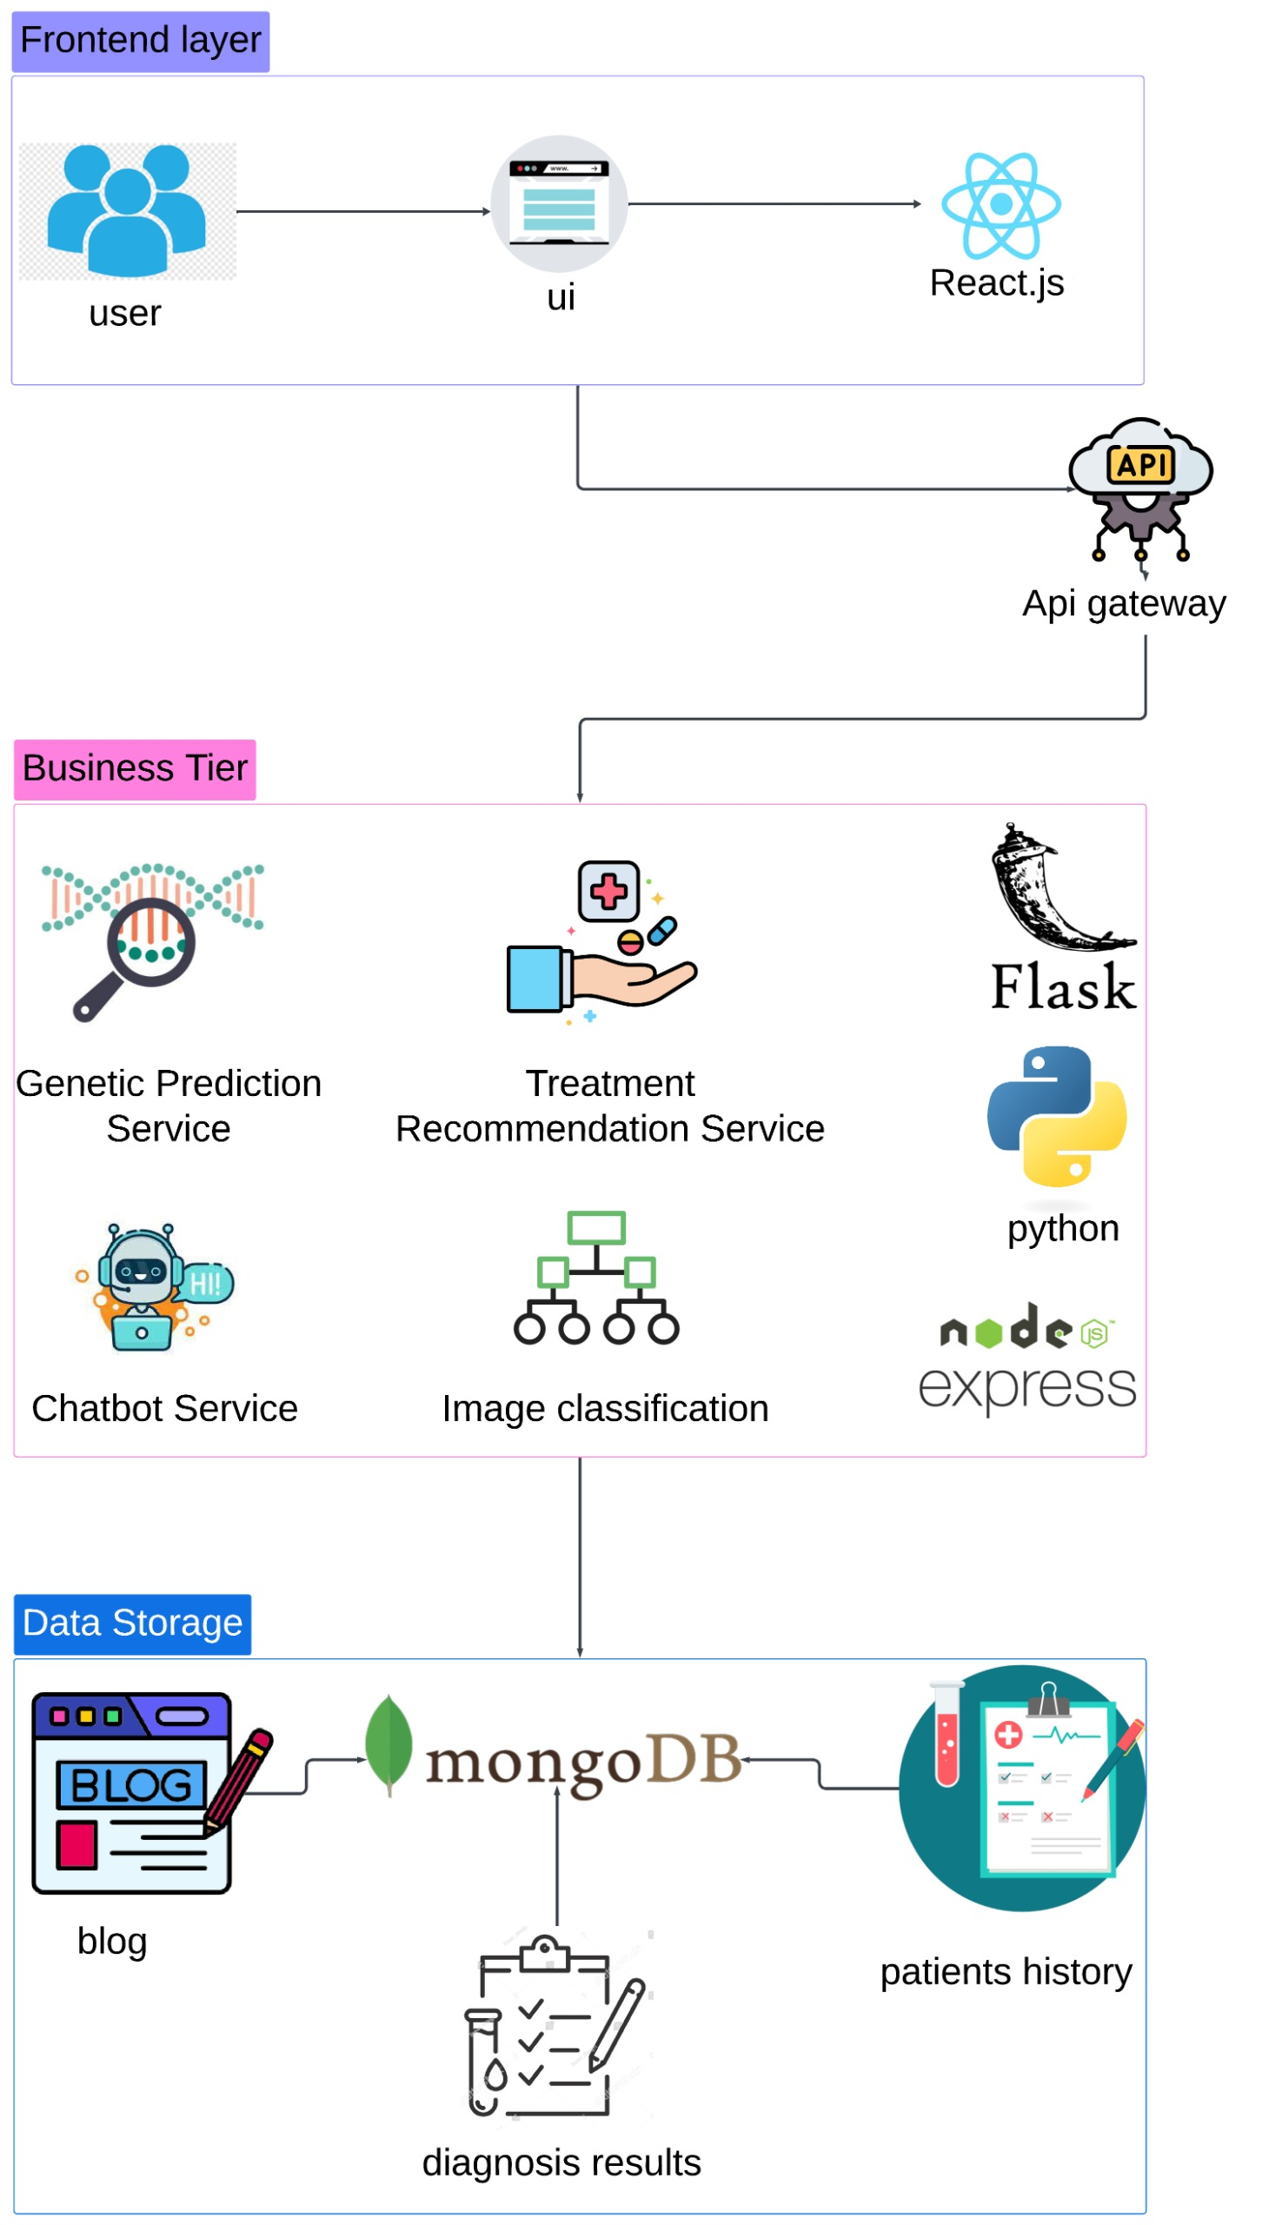

1. System Overview:

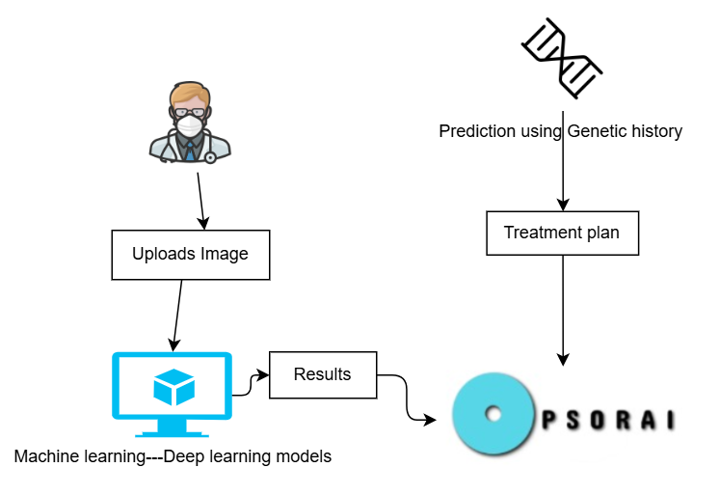

1. System Features list:

## Scope

The scope of this project is to create an AI-driven platform for enhancing psoriasis care. It will focus on using Machine learning and Deep learning models to classify psoriasis and it’s ‘similar in characteristics’ diseases and it’s subtypes from uploaded images, predict the likelihood of developing the condition based on genetic history, and provide personalized treatment recommendations. Additionally, the platform will include a patient management system for tracking medical history and progress, a blog section for awareness and community engagement, and location services to connect users with the best healthcare providers all across Egypt. This project aims to address the challenges of limited resources, awareness, and data availability in regions like Egypt and the Middle East.

## Project Overview

PSORAI not only focuses on predicting the possibility of the disease or detecting the type of skin issue but also on creating a platform for patients to feel included and have everything required to live with the disease. This system will house multiple features like a blog section for users to share stories and experiences, medical treatment spots, and the best dermatologists' location for each governate. The patient's progress details are also tracked as well as lifestyle recommendations to help the patient adapt.

# Similar System Information

## Similar System Description

The following research are the main papers gathered for each domain we have chosen for this project:

1. **Domain 1: Classification**

* Authors: Muhammad Sajid Rashid, Ghulam Gilanie, Saira Naveed, Sana Cheema, Muhammad Sajid.
* Year: Published in 2024.
* Title: "Automated Detection and Classification of Psoriasis Types Using Deep Neural Networks from Dermatology Images."
* Summary: This study proposes a lightweight Deep Neural Network (DNN)-based model for the automated detection and classification of five types of psoriasis from dermatology images. The model’s effectiveness is compared with pre-trained models such as GoogLeNet, InceptionV3, and VGG-19, showing superior classification performance. The research highlights the use of color space transformation (RGB to YCbCr) for better feature extraction.
* Results: The model achieved high classification accuracy across all five psoriasis types, with accuracy up to 99.89% for psoriatic arthritis. The YCbCr color space was identified as optimal for classifying psoriasis.
* Motivation of this work: Researchers aimed to address the challenge of accurately detecting and classifying various psoriasis types using automated methods, as early diagnosis significantly impacts treatment outcomes.
* The main problem statement of the work: Current systems struggle with accurately detecting and classifying psoriasis due to complex image features and the need for lightweight, efficient models.
* How the researchers contributed to solve the problem: They developed a lightweight Deep Neural Network (DNN) model optimized using color space transformation (RGB to YCbCr) to enhance feature extraction, outperforming traditional pre-trained models.
* What main results the researchers reach: The model achieved high classification accuracy, with up to 99.89% accuracy for psoriatic arthritis. The YCbCr color space transformation proved optimal for psoriasis classification.
* How do you think this paper is important for you: This paper is important to us because it provides a lightweight and efficient model for psoriasis classification, which we can build upon to enhance the detection system in our project.

1. **Domain 2: Genetic History**

* Authors: Nguyen Quoc Khanh Le, Duyen Thi Do, Trinh-Trung-Duong Nguyen, Ngan Thi Kim Nguyen, Truong Nguyen Khanh Hung, Nguyen Thi Thu Trang.
* Year: Published in 2021.
* Title: "Identification of gene expression signatures for psoriasis classification using machine learning techniques."
* Summary: This study aims to classify psoriasis using gene expression data to identify differentially expressed genes that could act as biomarkers for psoriasis. Using machine learning techniques like Random Forest and Support Vector Machines, the study identifies 35 genes, including FABP5, TGM1, and BCAR3, as potential biomarkers for distinguishing lesional from non-lesional skin. The study achieved high classification accuracy, suggesting that these gene signatures may be valuable for understanding and diagnosing psoriasis.
* Results: The Random Forest model achieved 98.3% accuracy, 98.6% recall, and 98% precision on training data, and 96.7% and 100% accuracy on two independent test datasets, respectively.
* Motivation of this work: Researchers wanted to identify gene expression signatures to enhance the understanding and classification of psoriasis, addressing the need for better biomarkers.
* The main problem statement of the work: The lack of robust biomarkers for distinguishing psoriasis lesions from non-lesional skin hampers precise diagnosis and treatment personalization.
* How the researchers contributed to solve the problem: They used machine learning techniques to identify 35 genes as potential biomarkers for psoriasis classification, including FABP5, TGM1, and BCAR3.
* What main results the researchers reach: The Random Forest model achieved 98.3% accuracy on training data and excellent performance on test datasets, confirming the effectiveness of these gene signatures.
* How do you think this paper is important for you: This paper is significant to us because it provides insights into gene expression and biomarkers that can inspire the genetic history feature of our project, particularly in predicting psoriasis risks and tailoring treatment recommendations.

1. **Domain 3: Diagnosis & Treatment**

* Authors: Mohammad Yaseliani, Abtin Ijadi Maghsoodi, Erfan Hassannayebi, and Uwe Aickelin.
* Year: Published in 2024.
* Title: "Diagnostic clinical decision support based on deep learning and knowledge-based systems for psoriasis: From diagnosis to treatment options."
* Summary: The study presents a Decision and Diagnostic Support System (D&DSS) for psoriasis using deep learning-based Computer-Aided Diagnosis (CAD) and treatment suggestions. The system utilizes an ensemble of Convolutional Neural Networks (CNNs) to classify psoriasis images and suggests optimal treatments based on Multi-Criteria Decision Making (MCDM) methods.
* Results: The proposed model achieved high accuracy, with 91.90% accuracy in binary classification and 93.29% in multi-class classification for different psoriasis types.
* Motivation of this work: The researchers aimed to provide a comprehensive system that supports clinicians in diagnosing psoriasis and suggesting optimal treatments, bridging gaps in existing diagnostic and treatment tools.
* The main problem statement of the work: The lack of an integrated diagnostic and treatment recommendation system for psoriasis complicates clinical decision-making and impacts patient outcomes.
* How the researchers contributed to solve the problem: They developed a Decision and Diagnostic Support System (D&DSS) combining deep learning for classification and Multi-Criteria Decision Making (MCDM) for treatment recommendations.
* What main results the researchers reach: The system achieved 91.90% accuracy in binary classification and 93.29% in multi-class classification of psoriasis types, demonstrating its reliability for clinical use.
* How do you think this paper is important for you: This paper is crucial for us as it aligns with our goal of developing a detection and treatment recommendation system, offering valuable insights into system design and integration.

# Project Management and Deliverable

## Tasks and Time Plan

* Timeline of the project:

August -- Mid-September- Idea gathering, Initial planning, Literature Review.

End of September -- October- Gathering datasets and planning a collaboration.

November -- Proposal (Milestone 1), Preprocessing and cleaning dataset to reach desired and balanced length.

December-- Classification of Model 1(Skin Diseases) & Model 2(Types of psoriasis), 1st research paper draft, Start of platform creation.

January- Grad 1(Milestone 2) 25% of project done: ML/DL models of first domain ready, research paper ready, Diagrams ready, models connected to website.

February-- March- Website ready with 45% of the features present and working on the website.

April-( Milestone 3) Features and website details is 65-70% done and running.

May--June- Grad 2 (Milestone 4 ) Website and project is done and ready for submission.

## Budget and Resource Costs

## As of now, this project is not funded and does not require any financial aid to start creating it.

* 1. **Supportive Documents**

** Add a survey result here if necessary to make one.

# References

* Rashid, M. S., Gilanie, G., Naveed, S., Cheema, S., & Sajid, M. (2024). Automated detection and classification of psoriasis types using deep neural networks from dermatology images. Signal, Image and Video Processing. <https://link.springer.com/article/10.1007/s11760-023-02722-9>
* Le, N. Q. K., Do, D. T., Nguyen, T.-T.-D., Nguyen, N. T. K., Hung, T. N. K., & Trang, N. T. T. (2021). Identification of gene expression signatures for psoriasis classification using machine learning techniques. iScience, 23(4), 1000018. <https://www.sciencedirect.com/science/article/pii/S2590124920300018>
* Yaseliani, M., Ijadi Maghsoodi, A., Hassannayebi, E., & Aickelin, U. (2024). Diagnostic clinical decision support based on deep learning and knowledge-based systems for psoriasis: From diagnosis to treatment options. Computers in Biology and Medicine, 163, 106778. <https://www.sciencedirect.com/science/article/pii/S0360835223007787>